ABASYN UNIVERSITY ISLAMABAD CAMPUS
CS375 - Mobile Application Development
Assignment No 4

NAME: Haad yousaf

REG NO: 8755

DEPARTMENT OF COMPUTING

- The app/product has been successfully uploaded/published

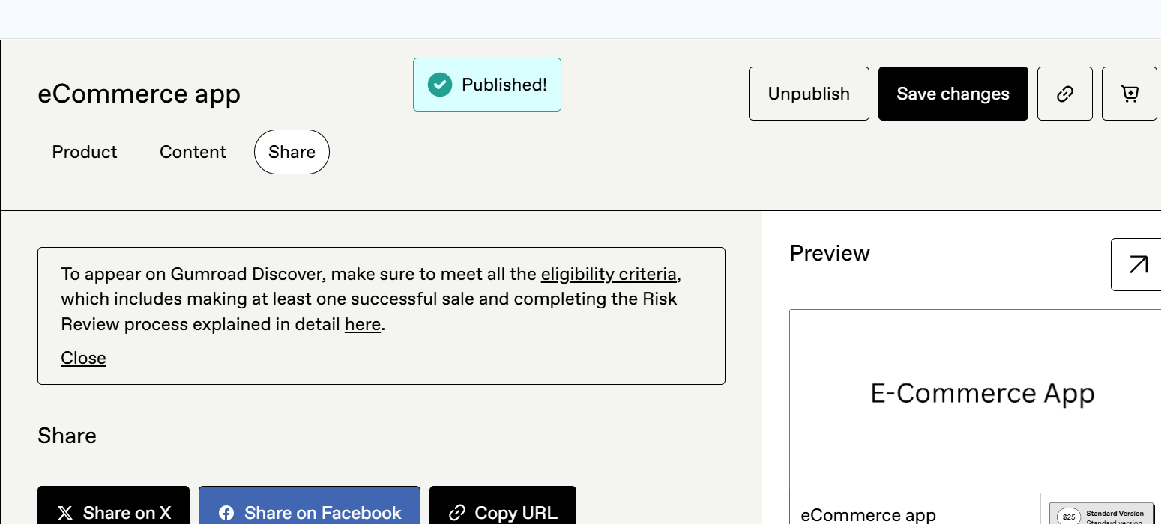

- The eCommerce mobile application has been successfully uploaded and published on the Gumroad platform.
- The product status shows “Published”, confirming that the listing is now live and publicly accessible.
- This verifies successful deployment of the application on a digital marketplace.

- Payoneer has been successfully added / integrated as a payment or payout option

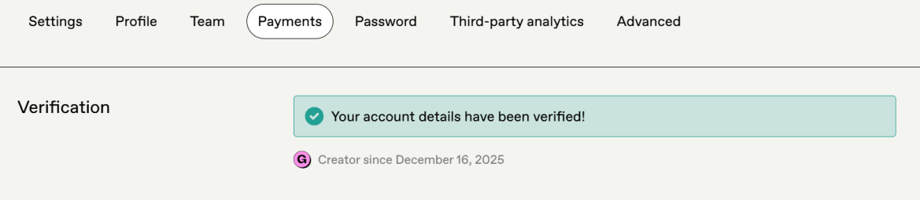

- The payment and payout settings have been successfully verified on Gumroad.
- The account verification status confirms that payouts are enabled and ready to be processed.
- Earnings from product sales will be received through the linked bank account according to Gumroad’s payout policy.

- Link

